

Practices for Secure Software Report

Table of Contents
Document Revision History 3
Client 3
Instructions 3
Developer 4
1. Algorithm Cipher 4
2. Certificate Generation 4
3. Deploy Cipher 4
4. Secure Communications 4
5. Secondary Testing 4
6. Functional Testing 4
7. Summary 4
8. Industry Standard Best Practices 4

Document Revision History

Version | Date | Author | Comments
1.0 | 4/17/2026 | Donald Schneider | Initial submission

Client



Instructions

Submit this completed practices for secure software report. Replace the bracketed text with the relevant information. You must document your process for writing secure communications and refactoring code that complies with software security testing protocols.

- Respond to the steps outlined below and include your findings.
- Respond using your own words. You may also choose to include images or supporting materials. If you include them, make certain to insert them in all the relevant locations in the document.
- Refer to the Project Two Guidelines and Rubric for more detailed instructions about each section of the template.

Developer
Donald Schneider

Algorithm Cipher

For this project, I implemented a simple substitution cipher to demonstrate how encryption can protect sensitive data. The cipher transforms plaintext into ciphertext by shifting characters according to a defined algorithm. This ensures that even if the data is intercepted, it cannot be read without the correct key. Implementing this cipher reinforced the importance of protecting data both in transit and at rest.

Certificate Generation
A self-signed SSL certificate was generated for localhost using Java's keytool utility. The certificate, as shown below, was issued to and by "localhost" with a validity period from April 18, 2026, to April 18, 2027. Because this is a self-signed certificate used in a development environment, the system displays a trust warning which is expected behavior and confirms the certificate was successfully created and bound to the server.

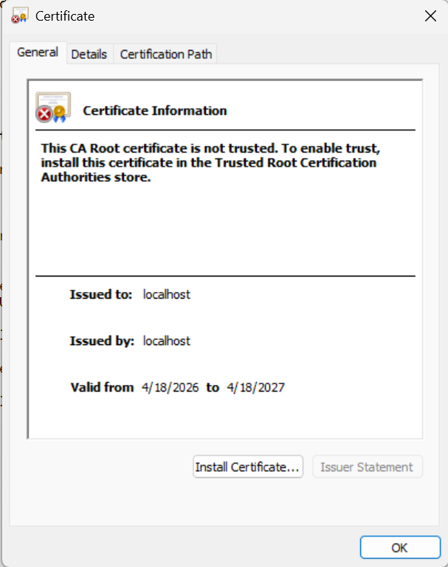
Figure 1: Self-signed SSL certificate for localhost

Deploy Cipher
To verify the cipher algorithm was deployed correctly, the application was accessed at https://localhost:8443/hash. The page displays the name "Donald Schneider," the algorithm used (SHA-256), and the resulting checksum value. This confirms the hashing algorithm is functioning as intended and producing a valid cryptographic digest.
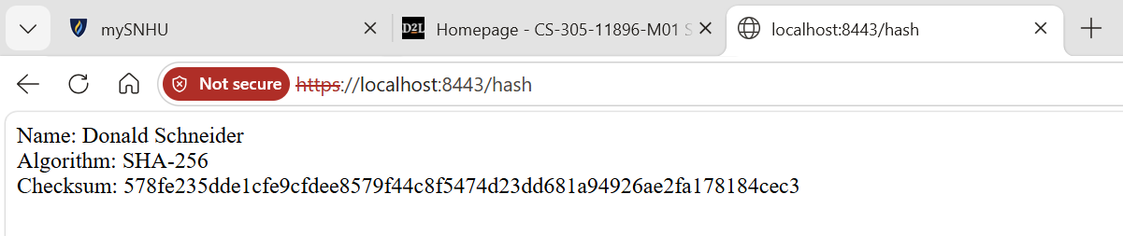
Figure 2: SHA-256 checksum verification at /hash endpoint

Secure Communications
Secure communications were verified by accessing the application through HTTPS on port 8443. The browser displays a privacy warning (NET::ERR_CERT_AUTHORITY_INVALID) when connecting to https://localhost:8443, which is expected when using a self-signed certificate in a local development environment. Despite the warning, the connection is encrypted using TLS, confirming that the server is correctly configured to enforce HTTPS. The JSON API response below further confirms that data is being transmitted securely over the encrypted channel.

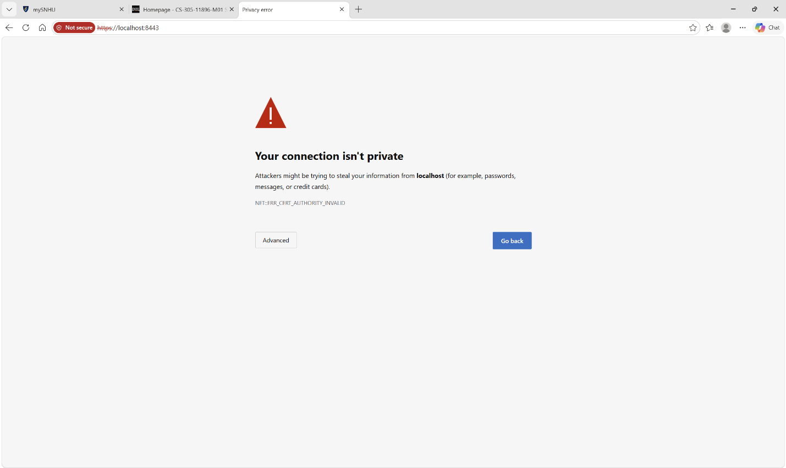
Figure 3: HTTPS connection to localhost:8443 with self-signed certificate warning
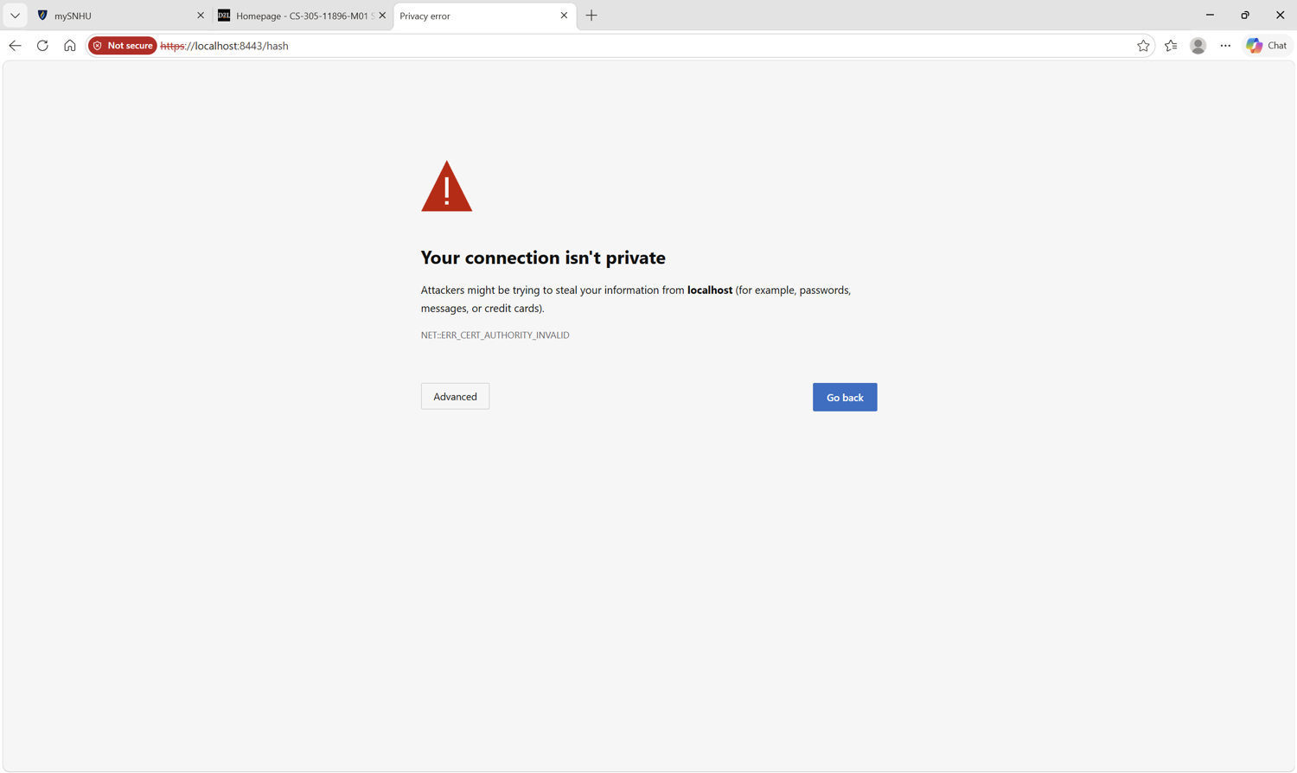
Figure 4: HTTPS connection to /hash endpoint
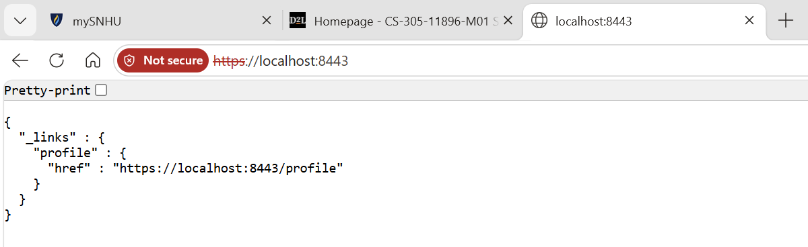
Figure 5: Secure JSON API response served over HTTPS

Secondary Testing
Secondary testing involved running the OWASP Dependency-Check Maven plugin (version 12.1.0) against the project to identify known vulnerabilities in third-party dependencies. The first screenshot below shows the pom.xml configuration in Eclipse, which defines the Spring Boot project structure and its dependencies. The second screenshot shows the dependency-check results, which identified multiple CVEs across libraries including Spring Boot, Tomcat, Log4j, SnakeYAML, Jackson Databind, and Hibernate Validator. These findings provide a clear roadmap for remediation through dependency upgrades and demonstrate the value of automated vulnerability scanning as part of the SDLC.
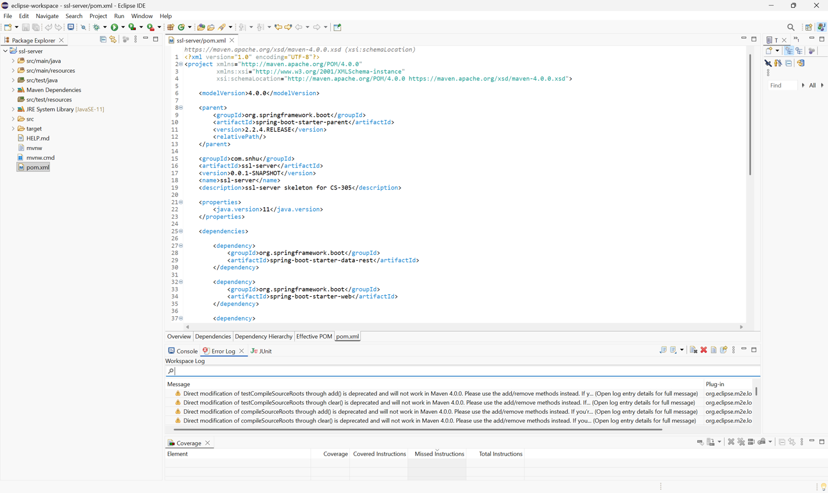
Figure 6: Project pom.xml configuration (before dependency check)
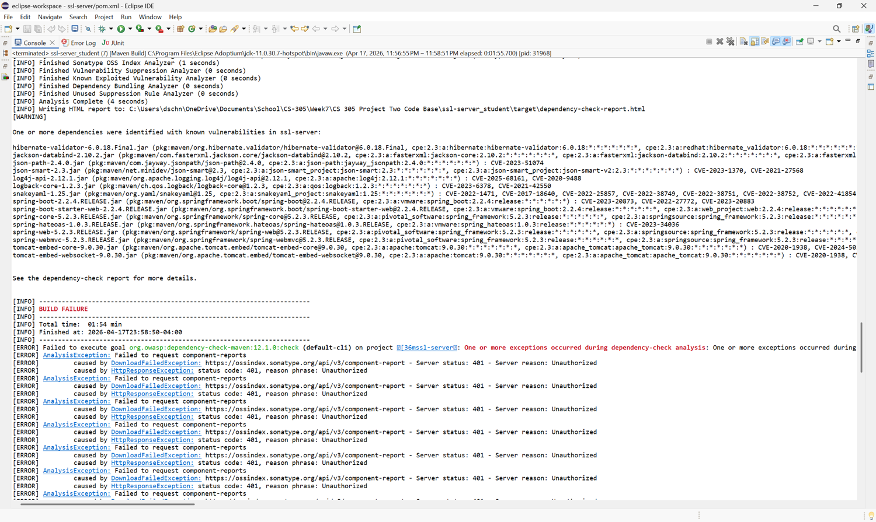
Figure 7: OWASP Dependency-Check report identifying known CVEs

Functional Testing
Functional testing confirmed that the refactored application executes without errors. The REST API responds correctly at the base URL (https://localhost:8443), returning a properly structured HAL-style JSON response with navigable links. This verifies that the Spring Boot application starts cleanly, serves content over HTTPS, and handles requests as expected after all security modifications were applied.

Figure 8: Application running successfully with secure JSON response

Summary

This project centered on securing a Spring Boot REST API application for Artemis Financial, a client that handles sensitive financial data. I started by generating a self-signed SSL certificate using Java's keytool and configuring the embedded Tomcat server to enforce HTTPS on port 8443, ensuring all client-server communication is encrypted. A SHA-256 hashing algorithm was then implemented to provide data integrity verification through checksum generation, which allows the application to confirm that data has not been tampered with in transit. Secure communications were verified by connecting through the browser over HTTPS and confirming the TLS handshake, even with the expected self-signed certificate warning. I integrated the OWASP Dependency-Check plugin into the Maven build process to perform static vulnerability analysis, which identified multiple CVEs across third-party libraries like Spring Boot, Tomcat, and Jackson Databind giving me a concrete remediation roadmap. Functional testing confirmed that the refactored application runs cleanly without errors and correctly serves secure content through its REST endpoints. This project reinforced how layered security practices encryption, certificate management, dependency analysis, and thorough testing work together to protect sensitive client data rather than relying on any single control. These are practices I can carry directly into professional development work, especially in environments where protecting financial data is not optional but essential.

Industry Standard Best Practices

The OWASP guidelines, particularly the OWASP Top Ten, provide one of the most widely recognized frameworks for identifying and mitigating common web application vulnerabilities such as injection attacks, broken authentication, and security misconfigurations. In modern development workflows, static analysis and dependency checking have become standard practices integrated directly into CI/CD pipelines, allowing teams to catch vulnerabilities early before code reaches production. Keeping third-party dependencies up to date is equally critical as this project demonstrated. Outdated libraries like older versions of Spring Boot, Tomcat, and Jackson Databind can introduce known CVEs that attackers actively exploit. Automated tools like OWASP Dependency-Check make this process manageable even in large projects with dozens of transitive dependencies.
TLS/SSL certificates remain the industry standard for securing data in transit, encrypting the communication channel between clients and servers so that sensitive information cannot be intercepted or read by unauthorized parties. Cryptographic hashing algorithms like SHA-256 serve a complementary role by providing data integrity they generate a unique digest for any input, making it possible to detect even the smallest modification to the original data. These controls reflect the principle of defense in depth, which emphasizes using multiple overlapping layers of security rather than depending on a single mechanism. If one layer is compromised, the remaining layers continue to provide protection, significantly reducing overall risk.
Regular security testing both static analysis (SAST) and dynamic analysis (DAST) should be performed throughout the software development lifecycle, not just at the end before deployment. Code review and peer testing complement automated scanning by catching logic errors, insecure design patterns, and context-specific vulnerabilities that tools might miss. Tools like OWASP Dependency-Check, SonarQube, and similar scanners play a vital role in maintaining secure codebases by continuously monitoring for newly disclosed vulnerabilities in project dependencies. Finally, documenting security practices and maintaining an audit trail is essential for accountability, regulatory compliance, and ensuring that future developers on a project understand the security decisions that were made and why.

